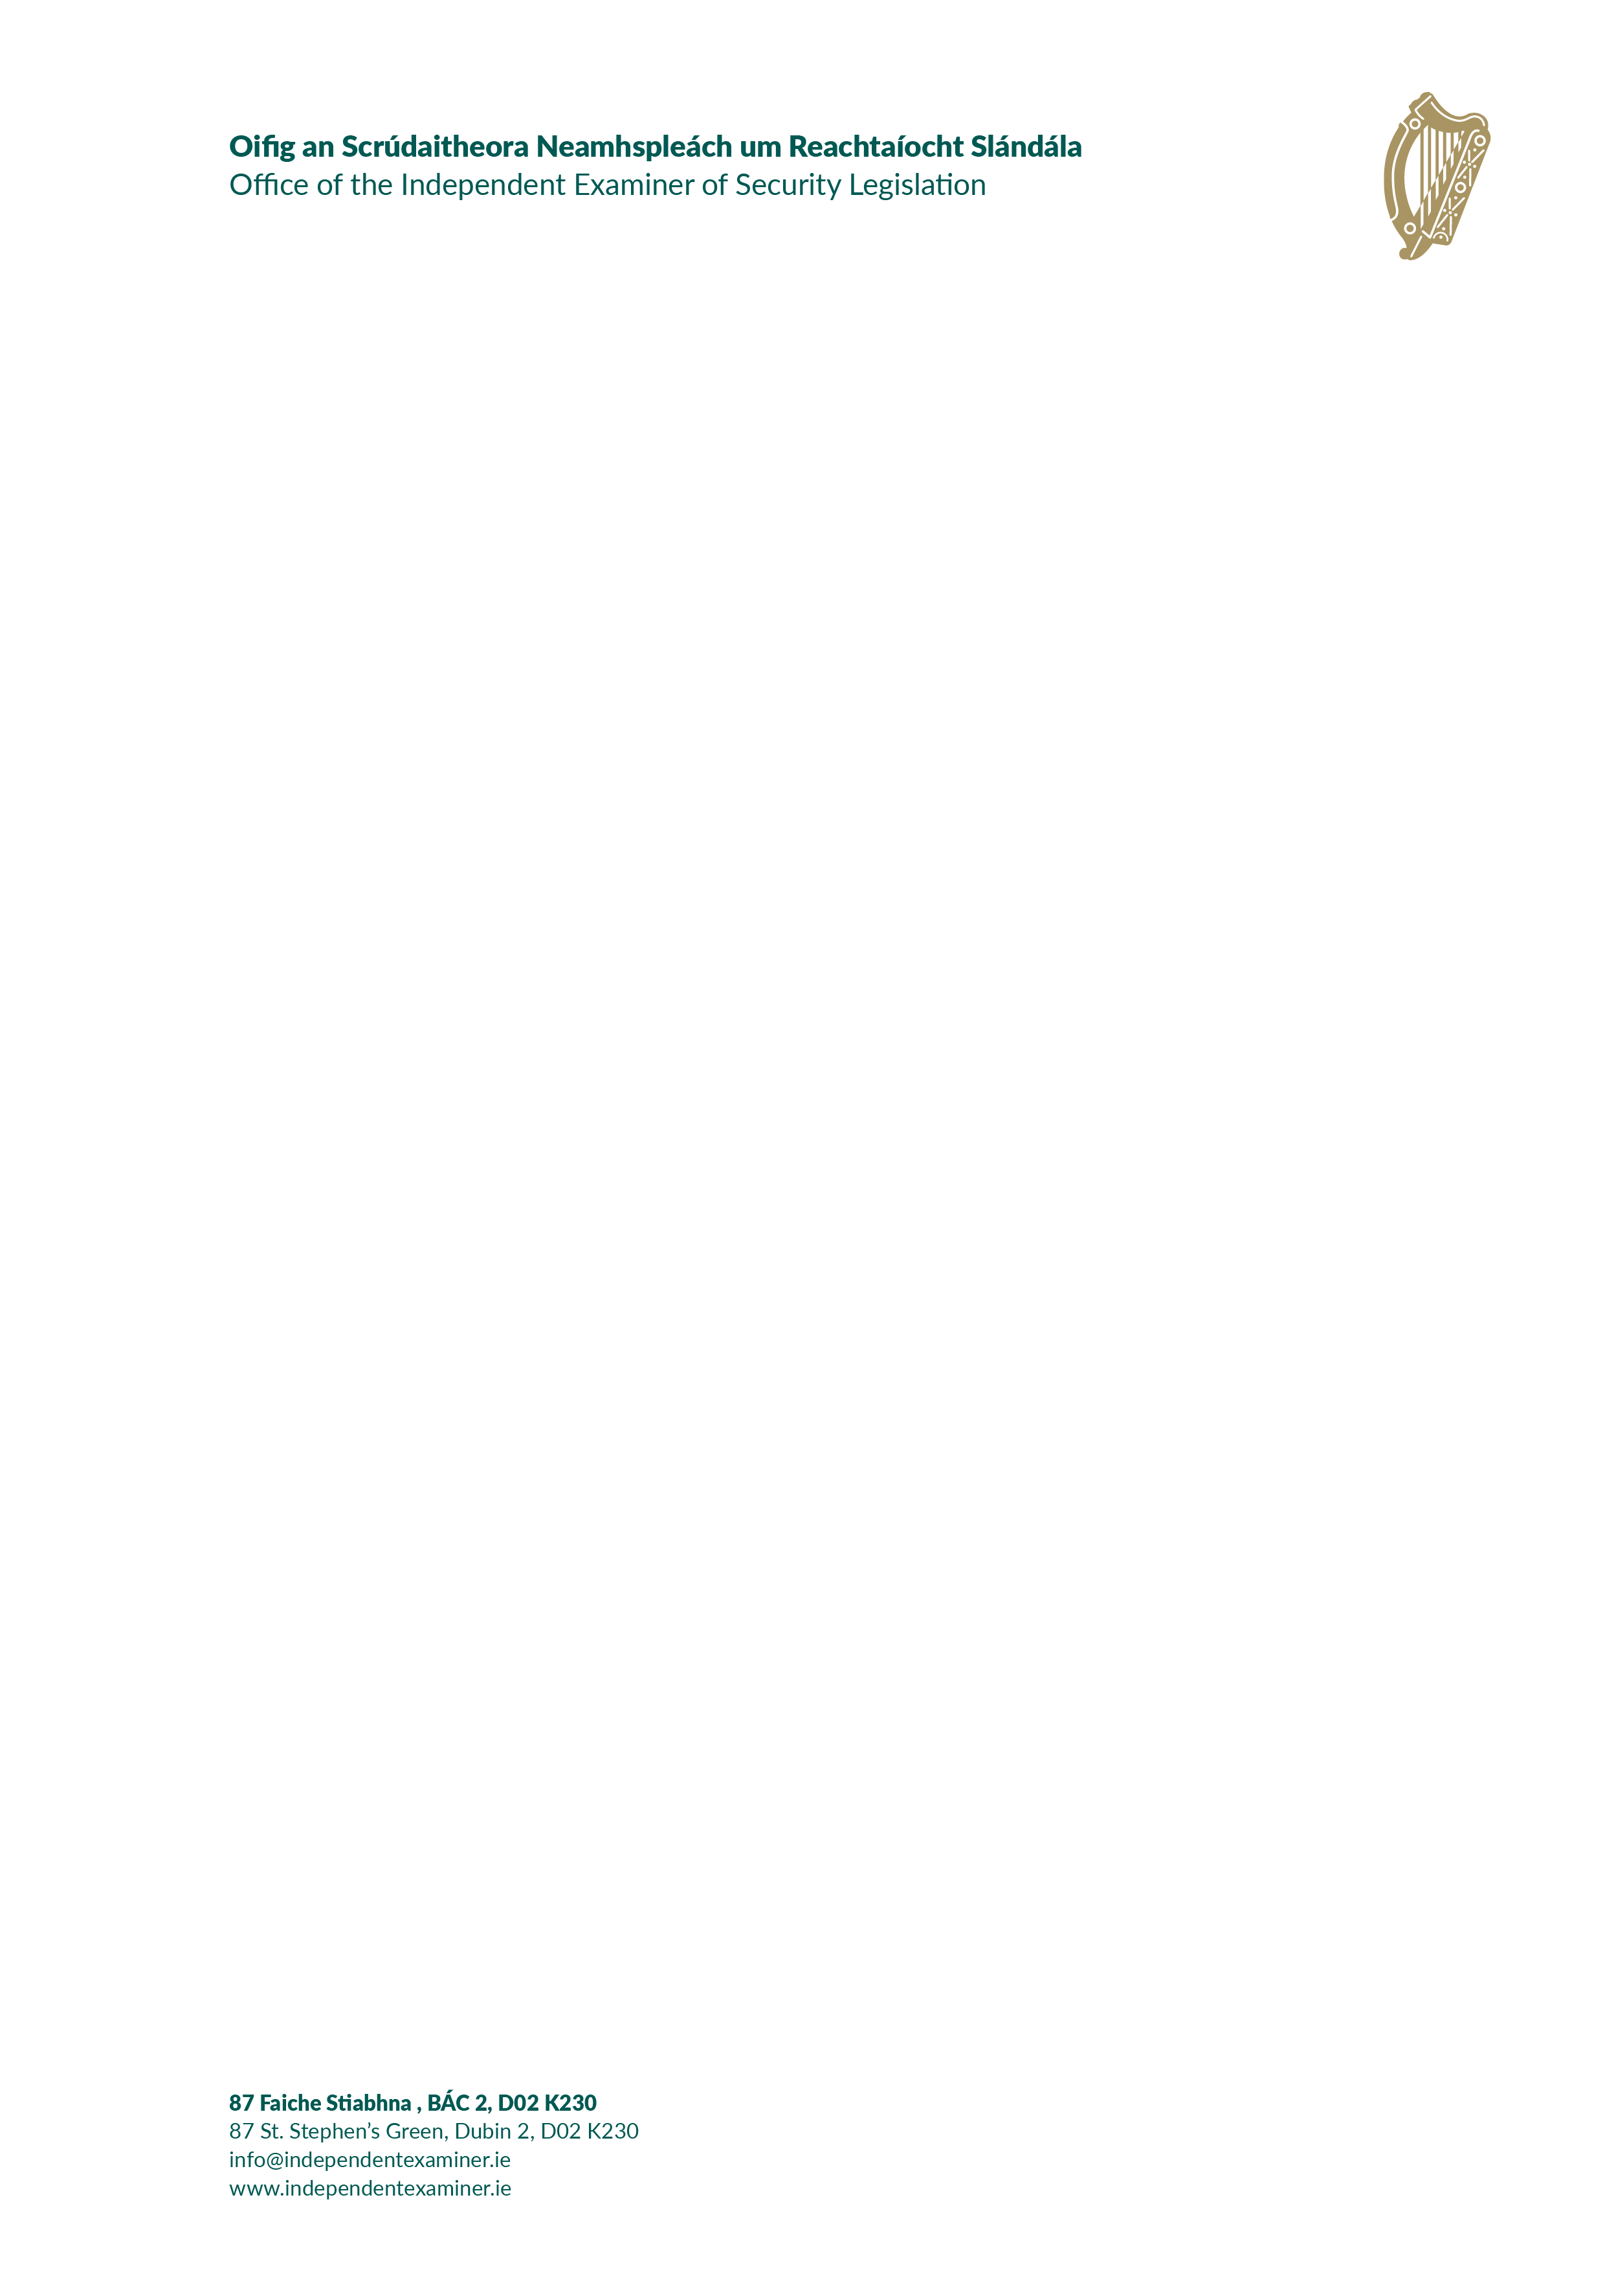

Press release
Independent Examiner of Security Legislation
publishes first Annual Report

22 April 2026
The Independent Examiner of Security Legislation has announced the publication of his first annual report under section 244(1) of the Policing, Security and Community Safety Act 2024. The report was submitted to the Taoiseach on 16 April 2026 and includes a review of the operation and effectiveness of three pieces of security legislation:
- The Interception of Postal Packets and Telecommunications Messages (Regulation) Act 1993
- The Criminal Justice (Surveillance) Act 2009, and
- The Communications (Retention of Data) Act 2011.
The report covers the period from the establishment of the office on 2 April 2025 to 31 December 2025 and sets out details of the Independent Examiner’s review visits to the bodies subject to oversight, the incidence of their use of statutory powers, as well as his observations and recommendations in relation to the legislation.
Independent Examiner George Birmingham said:
“I am delighted to publish this, my first annual report. In it, I make a number of recommendations, both for extending the powers available to agencies working in the security area, but also for procedural changes designed to strengthen and extend safeguards for the protection of human rights.
Work is already well underway to review further pieces of security legislation and to develop the strategic vision of the office.
In the body of the report, I have expressed my appreciation for the unstinting cooperation that I have received from all of the agencies I am required to oversee, and I take the opportunity of doing so here once again.
It has been said that government has no higher duty than ensuring the safety of the state. In my view, that is best achieved if those charged with maintaining the security of the state have adequate and appropriate powers available to them. Also, crucially, the public must be confident those powers are being exercised responsibly and in a proportionate manner, and that they are subject to effective review and oversight. I hope this report will serve as a positive contribution towards such review and oversight. ”

The Independent Examiner’s recommendations include:
Interception of Postal Packets and Telecommunications Messages (Regulation) Act 1993
- Develop legislative basis for interception of and access to modern, digital communications.
- Provide legislative basis for lawful access to all communications, including encrypted communications, incorporating appropriate safeguards.
- Examine potential models for prior judicial authorisation of interception applications.
Criminal Justice (Surveillance) Act 2009
- Provide for authorisation of tracking devices by superior officers on a short-term basis, with a requirement to seek judicial affirmation.
- Introduce legislative requirement for senior officers authorising urgent applications for surveillance or applications for tracking devices to be independent of the investigation or operation.
- Address the issue of the deployment of tracking devices after a period of four months’ monitoring.
Communications (Retention of Data) Act 2011
- Expressly and directly provide for powers under this Act for the Police Ombudsman in statute.
- Consider amending the legislation to provide for exceptions to the requirement that authorisations for cell site data for the purpose of protecting the life or personal safety of a person or for the location of a missing person may not be made by a senior officer having any prior involvement.
You can view/download the report on www.independentexaminer.ie.
Ends

Notes for editors:
The origins of the office of Independent Examiner of Security Legislation are to be found in a recommendation made in the report of the Commission on the Future of Policing in Ireland. Part 7 of the Policing, Security and Community Safety Act 2024 gave effect to that recommendation in providing for the establishment of the Independent Examiner of Security Legislation.
The Independent Examiner is an entirely new role and represents a significant development in enhancing Ireland’s national security infrastructure. It provides for the independent review of security legislation and security services in the State. The Independent Examiner’s functions include to:
• Keep under review the operation and effectiveness of security legislation to ensure that it remains necessary, proportionate, effective and that it contains sufficient safeguards for protecting human rights.
• Have a general examination function in relation to the delivery of security services. State offices and agencies with a security remit are obliged to cooperate with the Independent Examiner.
• Review cases where information holders may refuse to provide information to the Police Ombudsman or the Policing and Community Safety Authority (PCSA) on the grounds of security of the State.
The Independent Examiner has assumed the existing oversight roles formerly carried out by designated High Court judges, relating to the operation of statutory frameworks for the interception of communications, surveillance and data retention.
Reporting to the Taoiseach, the Independent Examiner is supported by an office and is empowered to produce other special reports and subject matter reports as necessary.
Short Biography of George Birmingham, Independent Examiner of Security Legislation
George Birmingham retired in 2024 as President of the Court of Appeal, having served for over six years in that role, which is the second most senior position in the Irish judiciary.
Educated at St Paul’s College, Raheny; Trinity College, Dublin and the King’s Inns, he was called to the Bar in 1976 and the Inner Bar in 1999. George was a member of Dáil Éireann from 1981 until 1989 and served as a Minister of State in a number of Government departments from 1982 until 1987. He was appointed to the High Court in 2007 and the Court of Appeal in 2014. George was appointed as President of the Court of Appeal in 2018.
For further biographical information, please visit the Office of the Independent Examiner of Security Legislation website at: https://independentexaminer.ie/about-us/
Contact:
- Layla de Cogan Chin - email LdeCoganChin@independentexaminer.ie, phone +353 87 2894190.
- Ronan Kyle - email RKyle@independentexaminer.ie, phone +353 87 2508929.

